Create the following graph using neo4j and answer the following query

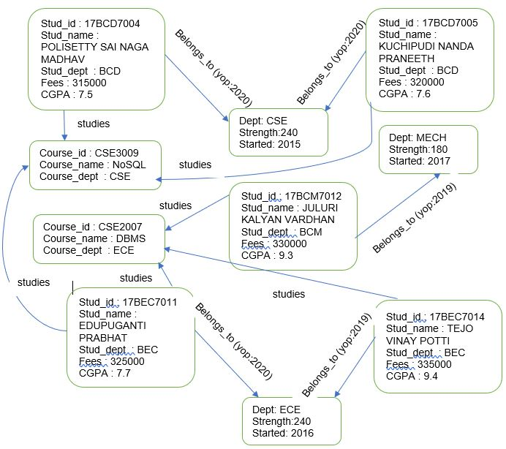

1. Display all student details.
2. Display all students who belong to ECE department
3. Display the all the department names
4. Display the student’s id who are all studying NoSQL course
5. Find the courses of student id 17BEC7011
6. Update the fees 10% increment for the students of CSE department
7. Add new property to all the course as “course_duration” and assign default value as 3
8. Display all the nodes names in the graph in ascending order
9. Display all the students of CSE and ECE
10. Display all the courses id and name.